## A INTERNSHIP REPORT ON

**SUBSCRIBER DATA MANAGEMENT**

***Submitted by,***

**Mr. Aneesh K - 20211IST0004**

### *Under the guidance of,*

**Mr. Srinivas Mishra**

***in partial fulfillment for the award of the degree of***

**BACHELOR OF TECHNOLOGY**

**IN**

**INFORMATION SCIENCE & TECHNOLOGY**

**At**



**PRESIDENCY UNIVERSITY**

**BENGALURU**

**MAY 2025**

**PRESIDENCY UNIVERSITY**

**PRESIDENCY SCHOOL OF COMPUTER SCIENCE AND ENGINEERING**

**CERTIFICATE**

This is to certify that the Internship report **“Subscriber Data Management”** being submitted by **ANEESH K** bearing roll number **20211IST0004** in partial fulfillment of the requirement for the award of the degree of Bachelor of Technology in Information Science and Technology is a bonafide work carried out under my supervision.

|  |  |
| --- | --- |
| **Mr. Srinivas Mishra**  Assistant professor,  PSCS  Presidency University | **Dr. Pallavi R**  Professor & HOD  PSCS  Presidency University |

|  |  |
| --- | --- |
| **Dr. MYDHILI NAIR**  Associate Dean  PSCS  Presidency University | **Dr. SAMEERUDDIN KHAN**  Pro-Vice Chancellor-Engineering  Dean –PSCS  Presidency University |

**PRESIDENCY UNIVERSITY**

**PRESIDENCY SCHOOL OF COMPUTER SCIENCE AND ENGINEERING**

**DECLARATION**

I hereby declare that the work, which is being presented in the report entitled “**Subscriber Data Management”** in partial fulfillment for the award of Degree of **Bachelor of Technology** in **Information Science & Technology**, is a record of my own investigations carried under the guidance of **Mr. SRINIVAS MISHRA, ASSISTANT PROFESSOR,** **Presidency School of Computer Science and Engineering, Presidency University, Bengaluru.**

I have not submitted the matter presented in this report anywhere for the award of any other Degree.

|  |  |
| --- | --- |
| Aneesh K, | 20211IST0004 |

**INTERNSHIP COMPLETION CERTIFICATE**

* **This certificate issued from Nokia Internship starting from, 21st October 2024 to 31st July 2025, Subscriber Data Management and I was an automation tester who is testing their OS of their product using Automation Framework.**

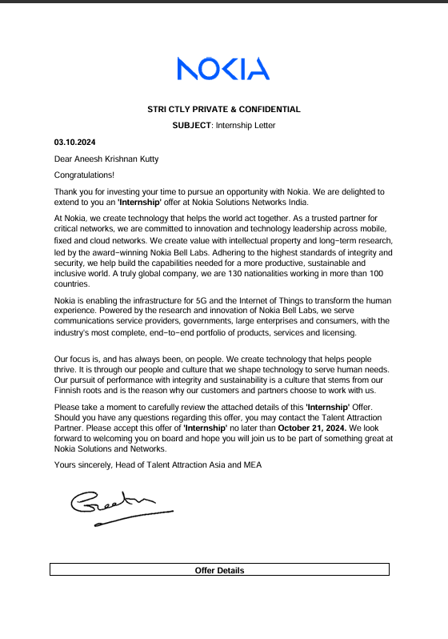

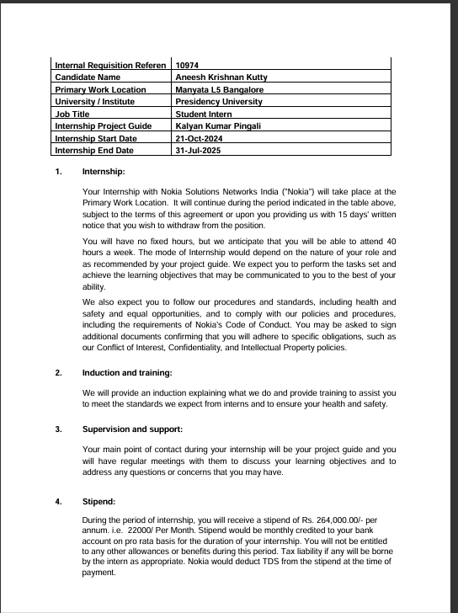

**ABSTRACT**

Nokia introduces the shared data layer as a single common data repository for the cloud by placing subscriber and session data into its own layer VNFs can be focused around only processing business logic making them truly stateless. Consequently, NFs become more flexible, scalable and easier to upgrade. The new and simplified cloud architecture makes cloud operation and maintenance easier while Nokia’s open api’s allow for faster introduction of new services with shared data layer subscriber and session data are readily available anytime and anywhere. Therefore in case of a network failover a new network element can catch up on the established session by retrieving the previously stored session state from the common data repository almost instantly and without service interruption due to the ubiquitous accessibility of user data simultaneous upgrading of multiple network elements is made possible without the need to wait for a maintenance because remaining network elements can simply retrieve relevant data from the shared data layer without service interruption. Nokia shared data layer is the key enabler for cloud optimized ultra robust highly scalable networks preparing cloud native network for future IOT and 5G technologies.

**ACKNOWLEDGEMENTS**

First of all, we indebted to the **GOD ALMIGHTY** for giving me an opportunity to excel in our efforts to complete this project on time.

We express our sincere thanks to our respected Dean **Dr. Md. Sameeruddin Khan**, Pro-VC - Engineering and Dean, Presidency School of Computer Science and Engineering & Presidency School of Information Science, Presidency University for getting us permission to undergo the project.

We express our heartfelt gratitude to our beloved Associate Dean **Dr. Mydhili Nair,** Presidency School of Computer Science and Engineering, Presidency University, and Dr. Pallavi R Head of the Department, Presidency School of Computer Science and Engineering, Presidency University, for rendering timely help in completing this project successfully.

We are greatly indebted to our guide **Mr. Srinivas Mishra, Assistant Professor** and Reviewer **Monisha Gupta, Assistant Professor**, Presidency School of Computer Science and Engineering, Presidency University for his inspirational guidance, and valuable suggestions and for providing us a chance to express our technical capabilities in every respect for the completion of the internship work.

We would like to convey our gratitude and heartfelt thanks to the PIP4004 Internship Coordinator **Mr. Md Ziaur Rahman and Dr. Sampath A K,** department Project Coordinators Mr. Srinivas Mishra and Git hub coordinator **Mr. Muthuraj.**

We thank our family and friends for the strong support and inspiration they have provided us in bringing out this project.

**ANEESH K**

**LIST OF TABLES**

|  |  |  |  |
| --- | --- | --- | --- |
| **Sl. No.** | **Table Name** | **Table Caption** | **Page No.** |
| 1 | Table 2.1 | Literature Survey | 3-4 |
| 2 | Table 3.1 | Research gaps of existing methods | 5-6 |
| 3 | Table 4.1 | Existing methodologies | 8 |

**LIST OF FIGURES**

|  |  |  |  |
| --- | --- | --- | --- |
| **Sl. No.** | **Figure Name** | **Caption** | **Page No.** |
| 1 | Fig 1.1 | SDL workflow | 2 |
| 2 | Fig 6.1 | Software Components | 12 |
| 3 | Fig 12.1 | Jenkins job | 23 |
| 4 | Fig 12.2 | Jenkins management job | 23 |
| 5 | Fig 12.3 | Jenkins job console output | 24 |
| 6 | Fig 12.4 | Gitlab Gui | 24 |
| 7 | Fig 12.5 | Setting up an SSH connection | 25 |
| 8 | Fig 12.6 | OpenStack dashboard | 25 |

**TABLE OF CONTENTS**

|  |  |  |
| --- | --- | --- |
| **CHAPTER NO.** | **TITLE** | **PAGE NO.** |
|  |  |  |
|  | **ABSTRACT**  **ACKNOWLEDGMENT** | **iv**  **v** |
|  |  |  |
| **1.** | **INTRODUCTION** | **1** |
|  |  |  |
| **2.** | **LITERATURE REVIEW** | **3** |
|  |  |  |
| **3.** | **RESEARCH GAPS OF EXISTION METHODS** | **5** |
|  |  |  |
| **4.** | **PROPOSED METHODOLOGY** | **7** |
|  |  |  |
| **5.** | **OBJECTIVES** | **10** |
|  |  |  |
| **6.** | **SYSTEM DESIGN & IMPLEMENTATION** | **12** |
|  |  |  |
| **7.** | **TIMELINE FOR EXECUTION OF PROJECT** | **13** |
|  |  |  |
| **8.** | **OUTCOMES** | **15** |
|  |  |  |
| **9.** | **RESULTS AND DISCUSSIONS** | **17** |
|  |  |  |
| **10.** | **CONCLUSIONS** | **18** |
|  |  |  |
|  | **REFERENCES** | **19** |
|  |  |  |
| **APPENDIX-A** | **PSUEDOCODE** | **21** |
|  |  |  |
| **APPENDIX-B** | **SCREENSHOTS** | **24** |
|  |  |  |
| **APPENDIX-C** | **ENCLOSURES** | **26** |
|  |  |  |
|  |  |  |

**Chapter 1**

**INTRODUCTION**

SDM which is the Subscriber Data Management, is analytical functions in telecommunication networks. It helps in 5G and manages all subscriber data. It is used to manage all the data in a single place and the network can be easily expanded and operated. The arrival of 5G and expansion to cloud architectures, the subscriber data services are managed securely and efficiently. Nokia’s shared data layer opens the way for a future end-to-end cloud architecture, a must for 5G as the market leader with hundreds of customer networks.

A number of concepts have been incorporated into the design of the 5GC since the system architecture must support use cases like AR, VR, real-time operations. Furthermore, N/w softwarization has grown in importance along with scalability and equipment investment protection. Thus, the goal of the 5GC network is to be:

1. **Adaptable:** 5GC ought to have the flexibility to set up the network on a common infrastructure and add new services as needed.
2. **Agile:** The 5GC should reduce the time it takes to deploy new services from hours to minutes and speed up their TTM from months to days.
3. **Scalable:** 5GC should have telco-grade dependability and be scalable quickly.
4. **Adjustable:** 5GC ought to be able to swiftly modify and enhance the network in accordance with operational circumstances. Additionally, it ought to facilitate the economic transition from 4G to 5G via an access-agnostic common core.
5. **Network slicing:** This feature allows for customisable network deployments and configurations based on the requirements of various services, independent scalability, and decoupled technical evolution.
6. **UA framework:** This helps operators provide "user behavior" services regardless of the access type and improves efficiency in multi-access cores using cloud computing and AI/ML concepts.
7. **“Stateless" network functions:** This feature separates the "compute” and "storage" resources. Cloud apps are the main source of this idea. It makes it possible to create and use network resources far more efficiently using techniques like virtualization, ai agents etc...
8. **Network capability exposure:** It is essential for operators to allow both internal and external apps to use the network's capabilities when they want to incorporate 5G with vertical industry operations as exposure to api's can lead to adding a new feature to the product.
9. **Mobile edge computing support:** This will enable low latency services h in nearby data centers. While the control-plane is centralized, user-plane functions are typically deployed remotely, that is, close to the user. It is also possible to distribute the control plane in mission-critical, very low-latency applications.

Figure 1.1 SDL workflow

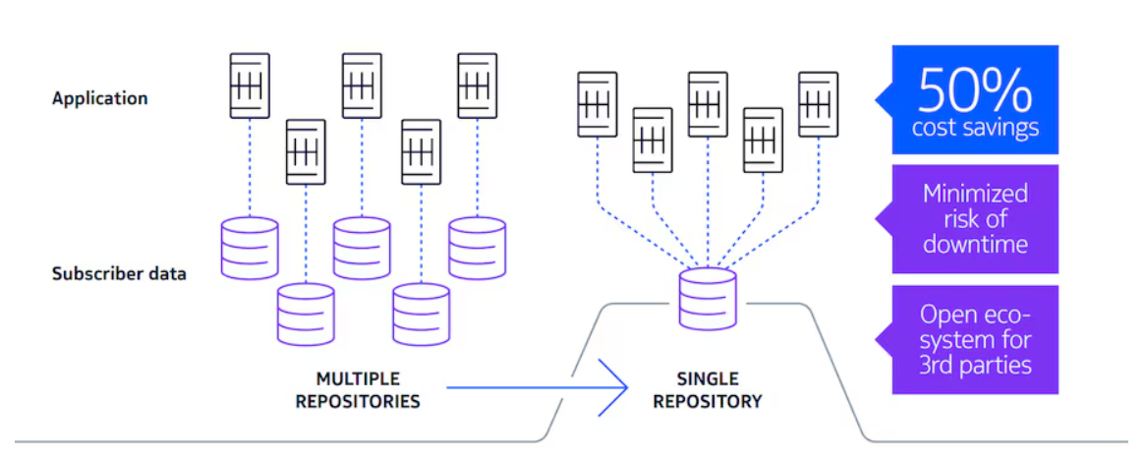

**Chapter 2**

**LITERATURE SURVEY**

Any project impact has a firm basis in understanding already available research, methods, and technologies. This chapter gives the literature review for the relevant work on the Subscriber Data Management.

**Subscriber Data Management Literature survey’s:**

Table 2.1 Literature Survey

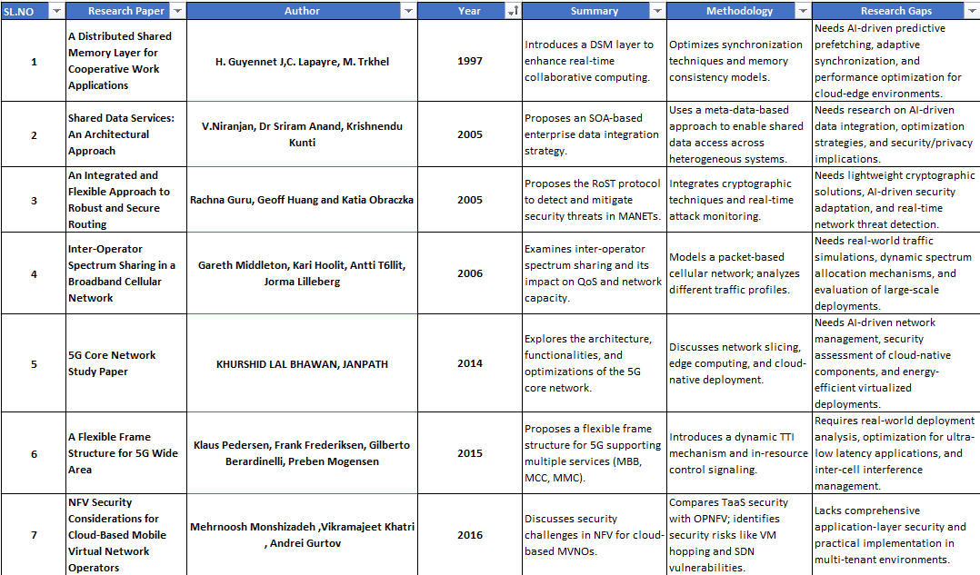

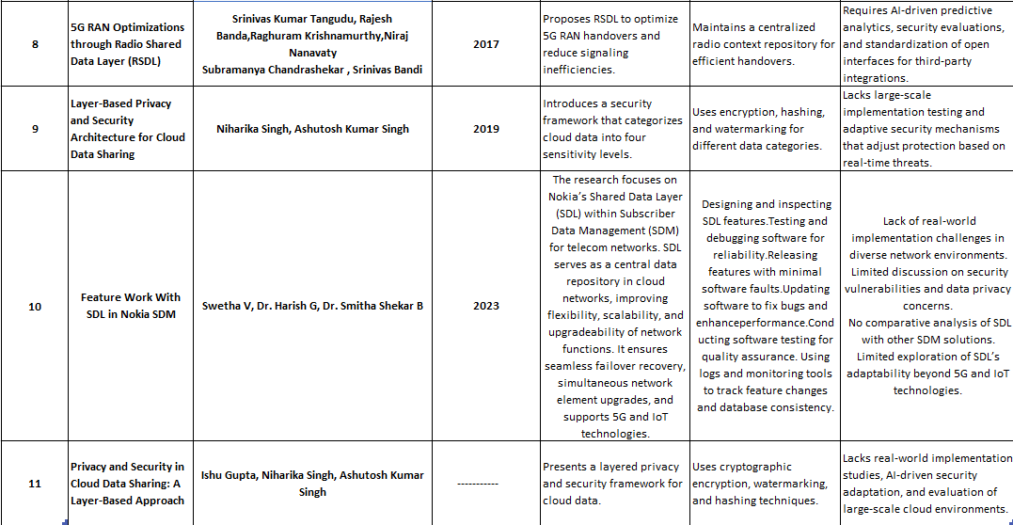

**Chapter 3**

**RESEARCH GAPS OF EXISTING METHODS**

Table 3.1 Research gaps of existing methods

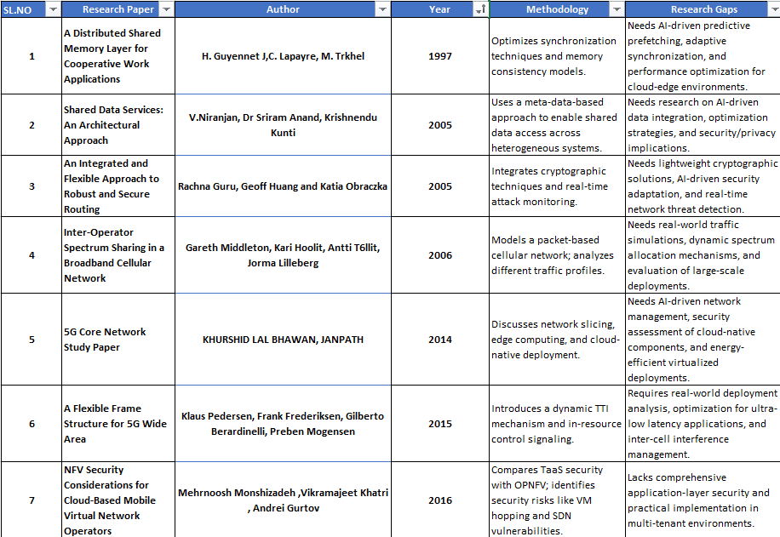

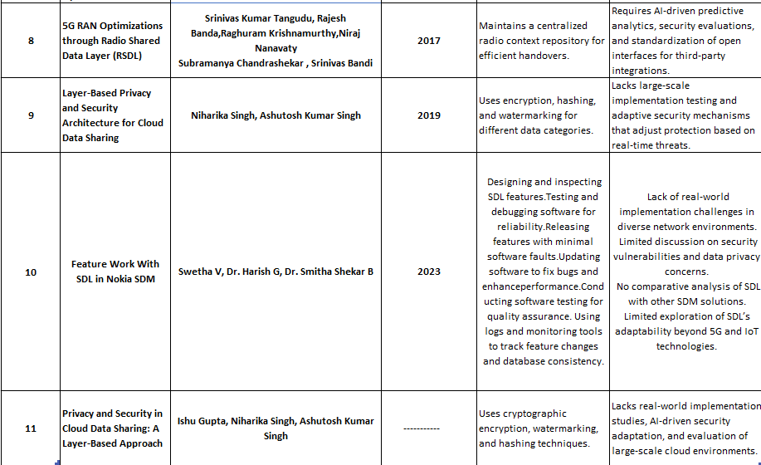

**Chapter 4**

**PROPOSED MOTHODOLOGY**

The proposed methodology aims to design and implement an integrated framework combining a National Importance Project Portal with an E-Commerce Website to address existing research gaps. The methodology involves a step-by-step approach, including requirement analysis, system design, development, testing, and deployment, ensuring a scalable, inclusive, and efficient system.

**4.1 System Requirements Analysis:**

The proposed system finds its footing in the realization of the different needs that its stakeholders would have. This preliminary step begins with a stakeholder analysis wherein telecom providers and vendors are engaged through surveys and interviews to outline their challenges and expectations. The proposed methodology for the development is agile scrum development using Devops operation .

For functional and non-functional requirements, it is designed to make the system shape according to technical as well as user expectancies. Core feature include high availability , highly scalable , distributed & resilient. Non-functional aspects like system scalability, security, and reliability have the highest priority in order to provide robustness and longevity in all usages. Mapping existing gaps against this set of requirements will help hone down on the focus of the system.

**4.2 Proposed Methodology:**

Additionally, gap mapping incorporates evidence from previous studies in the form of a specific description of what is lacking in solutions. These are a weak integration between the systems, lack of good digital inclusion, and also a poorly scaled solution. The analysis makes sure that the system is developed to bridge the gaps while having an resilient and highly available & scalable project.

The principal architect must design the shared data layer, work on features, and review the code. It is necessary to promote the feature design following successful testing. It is impossible for the software to be error-free during the initial stages of production. Because of human mistake, there is a greater chance of software defects or flaws in the feature delivery. These problems can be resolved by applying software updates and repairing flaws. For end users, these software updates are straightforward and quick to use. They can be made automatically or by manually pressing the update button when the operating system or applications are first started. The software maintenance life cycle, which assesses and enhances software quality, heavily relies on software testing.

**4.3 Existing Methodologies:** Table 4.1 Existing methodologies

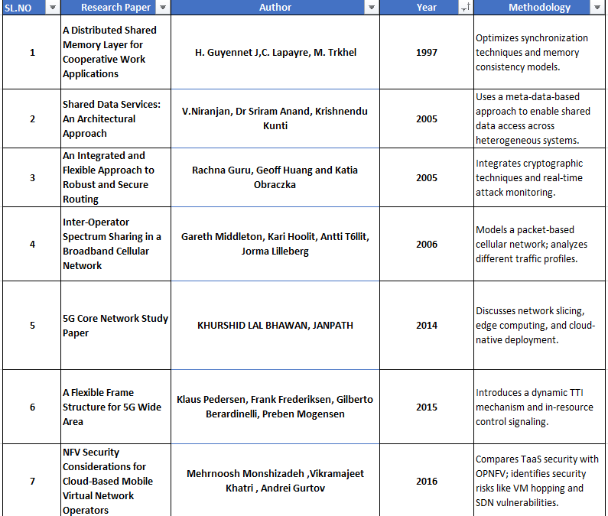

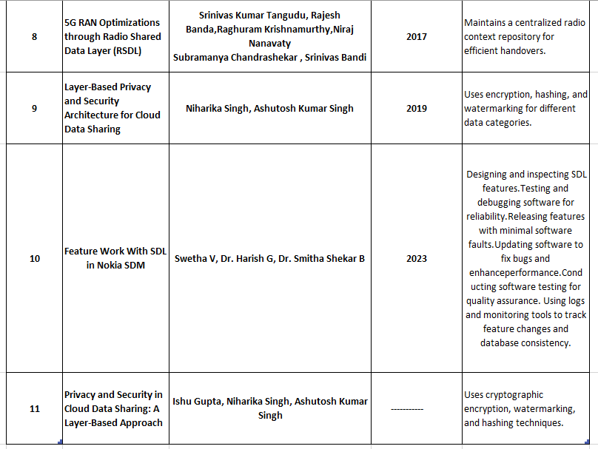

**Chapter 5**

**OBJECTIVES**

The new 5G Core N/w (5GC), often referred to as the 5GC NXTGN N/w, is a key component of the 5G architecture. It will serve as the network's central hub and facilitate the wide range of 5G services and applications. The 5G architecture and basic design principles have been described in the following parts. Additionally listed are the 5GC ideas that enable the 5GC to be robust, highly available, and agile, such as network slicing and service-based architecture.

A number of concepts have been incorporated into the design of the 5GC since the system architecture must support use cases like AR, VR, real-time operations. Furthermore, N/w softwarization has grown in importance along with scalability and equipment investment protection. Thus, the goal of the 5GC network is to be:

1. **Adaptable:** 5GC ought to have the flexibility to set up the network on a common infrastructure and add new services as needed.
2. **Agile:** The 5GC should reduce the time it takes to deploy new services from hours to minutes and speed up their TTM from months to days.
3. **Scalable:** 5GC should have telco-grade dependability and be scalable quickly.
4. **Adjustable:** 5GC ought to be able to swiftly modify and enhance the network in accordance with operational circumstances. Additionally, it ought to facilitate the economical transition from 4G to 5G via an access-agnostic common core.
5. **Network slicing:** This feature allows for customisable network deployments and configurations based on the requirements of various services, independent scalability, and decoupled technical evolution.
6. **UA framework:** This helps operators provide "user behavior" services regardless of the access type and improves efficiency in multi-access cores using cloud computing and AI/ML concepts.
7. **“Stateless" network functions:** This feature separates the "compute” and "storage" resources. Cloud apps are the main source of this idea. It makes it possible to create and use network resources far more efficiently using techniques like virtualization, ai agents etc...
8. **Network capability exposure:** It is essential for operators to allow both internal and external apps to use the network's capabilities when they want to incorporate 5G with vertical industry operations as exposure to api's can lead to adding a new feature to the product.
9. **Mobile edge computing support:** This will enable low latency services h in nearby data centers. While the control-plane is centralized, user-plane functions are typically deployed remotely, that is, close to the user. It is also possible to distribute the control plane in mission-critical, very low-latency applications.

**Chapter 6**

**SYSTEM DESIGN & IMPLEMENTATION**

**Software and Hardware Details:**

**Software Components:**

1. OpenStack
2. Red hat
3. Ceph
4. Linux
5. Jenkins

**Hardware Components:**

1. Intel CPU 2.1GHz
2. Memory – 500 GB
3. DDR
4. SSD
5. Server

Figure 6.1 Software Components

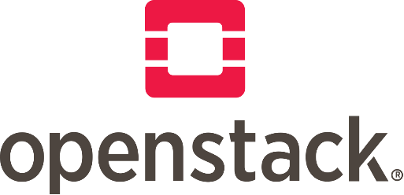



**Chapter-7**

**TIMELINE FOR EXECUTION OF PROJECT**

**(GANTT CHART)**

Nokia's SDL (Shared Data Layer) timeline highlights key developments in their core network architecture, including the launch of SDL in 2020, followed by various 5G core network deployments and partnerships, and continues with ongoing advancements in cloud-native core networks and 5G SA solutions.

**Early SDL Development & 5G Core:**

1. Initial Phase (2016): In 2016, Nokia launched the Shared Data Layer (SDL) to aid telecommunications companies in their shift to 5G and the Internet of Things (IoT).
2. By 2017, Nokia highlighted the SDL's importance in rendering Virtualized Network Functions (VNFs) stateless, which facilitated enhanced flexibility, scalability, and simpler upgrades, as demonstrated in a YouTube video.
3. Transition to 5G (2020-2023): In 2020, Nokia implemented its Unified Data Management, incorporating the Shared Data Layer, during China Unicom's inaugural 5G standalone call, enabling capabilities such as network slicing. In 2021, Nokia started deploying its 5G Standalone Core, which includes the SDL, for Telia in Finland. By 2022, Nokia expanded its collaboration with Orange through a 5G Core agreement, further showcasing the SDL's significance in 5G rollouts. In 2023, Nokia unveiled new 4G and 5G core network software solutions for enterprise sectors, underscoring the SDL's adaptability.
4. Current Progress: At present, Nokia continues to incorporate the SDL into various core network frameworks, including its 5G Core (5GC). Currently, Nokia's SDL facilitates data consolidation and carrier-grade reliability, supporting both traditional and 5G networks, as stated on Nokia's website. Presently, Nokia's SDL offers open APIs for developers to access data within the core network, enabling the development of new 5G-related applications.

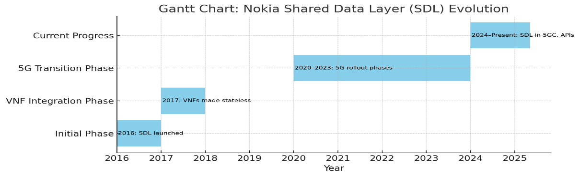

**Chapter 8**

**OUTCOMES**

Nokia's Shared Data Layer (SDL) product is designed to support cloud-optimized, extremely reliable, and highly scalable networks, equipping them for upcoming IoT and 5G technologies while offering advantages such as unified data exposure and new cloud revenue opportunities.

* Cloud-Native Architecture: SDL is crafted to promote a cloud-native approach to network infrastructure, enhancing its efficiency and adaptability.
* Scalability and Robustness: It delivers a highly scalable and robust solution for managing subscriber and session data, essential for meeting the demands of 5G and IoT.
* Data Management: SDL acts as a central repository for subscriber data, allowing operators to manage and utilize this data effectively.
* Single Point of Provisioning: It provides a single point of provisioning for network applications, simplifying operations and reducing complexity.
* Data Analytics and Monetization: SDL includes built-in capabilities for extracting, analysing, and presenting data, enabling operators to monetize data and develop new services.
* Open APIs: SDL supports open APIs, facilitating integration with other systems and enabling new services and applications.
* Stateless VNFs: SDL supports stateless VNFs, which are less complex and easier to manage than traditional VNFs, simplifying cloud operations.
* 5G Readiness: SDL is a vital component of the 5G core network, managing subscriber data across all technologies, from 2G to 5G.
* SDM (Subscriber Data Management): SDL is a crucial part of Nokia's SDM solution, which centralizes user data in a secure, highly scalable repository.
* Cost Savings: By consolidating multiple back-end repositories into one, SDL can result in significant cost savings and reduced downtime.
* Network Function Virtualization (NFV): SDL supports the transition of network functions to cloud-native VNFs, enhancing efficiency and flexibility.
* IoT and 5G: SDL is designed to prepare operator networks for the demands of the programmable world, IoT, and 5G.

Analytics, Charging, Policy, Signaling, and Network Exposure: Nokia's core network offerings include advanced analytics, flexible charging and policy management, robust signaling capabilities, and comprehensive network exposure solutions, enabling CSPs to build a future-proof and intelligent network.

**Chapter 9**

**RESULTS AND DISCUSSIONS**

**RESULTS & DISCUSSION:**

The feature is developed or implemented based on the customer requirements. The feature must be bug free and deployed after every phase. The components feature can be changed based on the requirements and these changes must not cause failure to the other components. Every change made must be reflected in the database. The separate logs are maintained for the developed feature and the changes made in each component must reflect in the database. Separate tools are required to test the feature. Therefore, the feature is inbuilt and meets the customer requirements. A lot of regression testing is done in the particular software version released using agile scrum methodology. While testing the software a lot of manual effort is needed so to mitigate it automation scripts is being used for testing which reduces the time for testing. As AI is booming, they are going to integrate it in the upcoming releases of the software.

The telecom industry and service providers are profits of SDM. The customer’s data is integrated into a single database by a service provider. They use artificial intelligence and build predictive analysis. The discovery of subscriber data mainly focuses on the issue for network operators. Therefore, the subscriber data which is saved in non-unified distributed architecture. Also, it is vendor-specific network elements and services that are more expensive to integrate the data. SDM approach addresses this difficulty by consolidating the subscriber data into a single repository.

Today operators live in a highly competitive market where the boundaries between traditional telecom services and the IT domain are fading. Following these developments the telco industry is actively implementing cloud computing to support continuous innovation and resilience to react to market demands. Nokia takes the next step into helping operators make their virtual network functions leaner and more efficient in other words making them cloud native to enable cloud native VNFs. Based on the SDM market leadership, Nokia uses the same principle to build SDL. Nokia SDM facilitates and provides a centralized, streamlined, high performing system for storing and processing information. SDM assists telecom operators and makes a transition to 5G. At the heart of the 5G Core, it delivers a unified platform to hold up 4G and 5G data.

**Chapter 10**

**CONCLUSION**

A key component of contemporary telecom developments, especially with the advent of 5G and the Internet of Things, is Subscriber Data Management (SDM). SDM solves issues like fragmented data, haphazard interfaces, and excessive operating expenses by combining subscriber data into a single repository. Telecom operators may make well-informed, data-driven decisions thanks to this unified strategy, which guarantees smooth data handling.

This invention is further expanded by Nokia's Shared Data Layer (SDL), which offers a high-performing solution that supports both 4G and 5G networks and incorporates cloud-native designs. The ops, rtdb, ntf, tlm, diag, and discovery components of SDL provide strong functions that improve data performance, dependability, and accessibility. SDL guarantees seamless operation and maintenance with features like centralized logging, performance monitoring, and fault management.

SDM and SDL help telecom operators manage the exponential expansion in subscriber data and connected devices as we move into the IoT era. These technologies enable carriers to provide individualized and effective services, such as mobile roaming notifications and geolocation-based services. Additionally, their cloud-native architecture guarantees low latency, scalability, and ultra-reliability—all essential for meeting the changing needs of 5G and the Internet of Things.

All things considered, SDM and SDL are essential for telecom operators to prosper in a cutthroat market, link millions of devices with ease, and effectively handle subscriber data, opening the door for further innovation in the telecom sector.

**REFERENCES**

1. Nokia_Shared_Data_Layer_White_Paper_EN.pdf
2. Innovate_and_execute_with_a_simplified_5G_core_.pdf
3. SDL overview.mp3
4. OPS & NTF architecture.mp3
5. RTDB architecture.mp3
6. DIAG & TLM architecture.mp3
7. CIT&CCoverview.mp3
8. https://www.nokia.com/networks/core-networks/shared-data-layer/
9. <https://www.nokia.com/about-us/sustainability/our-approach/nokia-and-the-united-nations-sustainable-development-goals/>
10. R. Guru, G. Huang and K. Obraczka, "An integrated and flexible approach to robust and secure routing for wireless multihop ad-hoc networks," Proceedings. 14th International Conference on Computer Communications and Networks, 2005. ICCCN 2005., San Diego, CA, USA, 2005
11. Pikkarainen, M., Vierimaa, M., Tanner, H., Suikki, R. (2004). Automatic Measurement at Nokia Mobile Phones: A Case of SDL Based Software Development. In: Bomarius, F., Iida, H. (eds) Product Focused Software Process Improvement. PROFES 2004. Lecture Notes in Computer Science, vol 3009. Springer, Berlin, Heidelberg
12. I. Gupta, N. Singh and A. K. Singh, "Layer-based Privacy and Security Architecture for Cloud Data Sharing," in Journal of Communications Software and Systems, vol. 15, no. 2, pp. 173-185, April 2019
13. MOBILE DIVISION & TELECOMMUNICATION ENGINEERING CENTRE. (2021). STUDY PAPER ON 5G CORE NETWORK. In TELECOMMUNICATION ENGINEERING CENTRE [Report].
14. H. Guyennet, J. . -C. Lapayre and M. Trehel, "Distributed shared memory layer for cooperative work applications," Proceedings of 22nd Annual Conference on Local Computer Networks, Minneapolis, MN, USA, 1997
15. Feature work with SDL in Nokia SDM. In Department of Computer Science and Engineering & Dr. Ambedkar Institute of Technology, Bangalore, India, International Journal of Creative Research Thoughts (IJCRT) (Vol. 11, Issue 1).
16. G. Middleton, K. Hooli, A. Tolli and J. Lilleberg, "Inter-Operator Spectrum Sharing in a Broadband Cellular Network," 2006 IEEE Ninth International Symposium on Spread Spectrum Techniques and Applications, Manaus, Brazil, 2006
17. V. Niranjan, Sriram Anand and Krishnendu Kunti, "Shared data services: an architectural approach," IEEE International Conference on Web Services (ICWS'05), Orlando, FL, USA, 2005
18. A flexible frame structure for 5G wide area. (2015). [Journal-article].
19. M. Monshizadeh, V. Khatri and A. Gurtov, "NFV security considerations for cloud-based mobile virtual network operators," 2016 24th International Conference on Software, Telecommunications and Computer Networks (SoftCOM), Split, Croatia, 2016
20. K. Pedersen, F. Frederiksen, G. Berardinelli and P. Mogensen, "A Flexible Frame Structure for 5G Wide Area," 2015 IEEE 82nd Vehicular Technology Conference (VTC2015-Fall), Boston, MA, USA, 2015, pp. 1-5
21. S. K. Tangudu, N. Nanavaty, R. Banda, S. Chandrashekar, R. Krishnamurthy and S. Bandi, "5G RAN optimizations through radio shared data layer (RSDL)," 2017 IEEE International Conference on Advanced Networks and Telecommunications Systems (ANTS), Bhubaneswar, India, 2017

**APPENDIX-A**

**PSUEDOCODE**

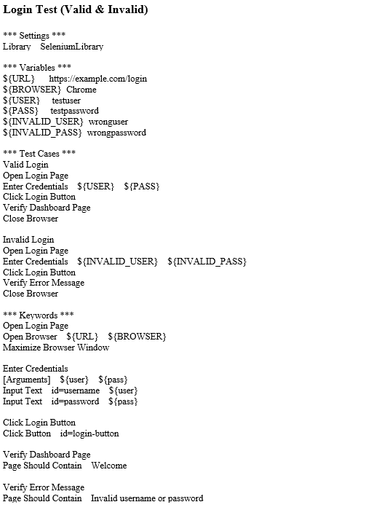

**Logout Test**

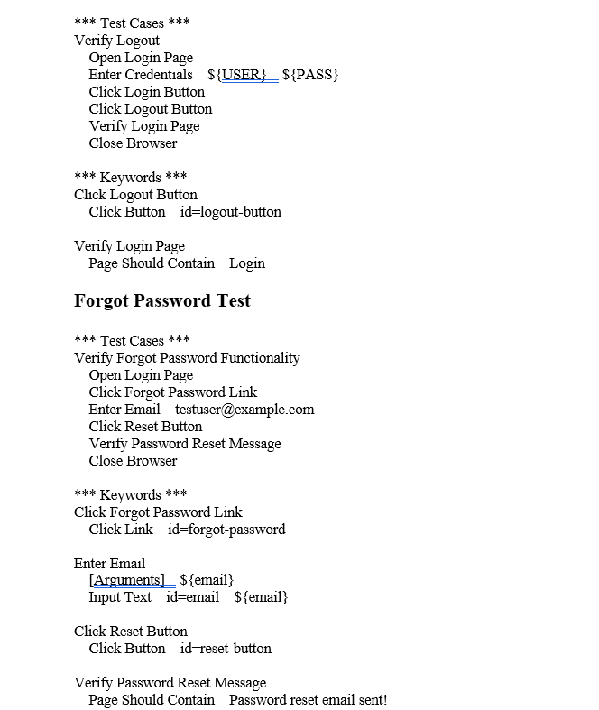

**APPENDIX-B**

**SCREENSHOTS**

Figure 12.1 Jenkins job



Figure 12.2 Jenkins management job

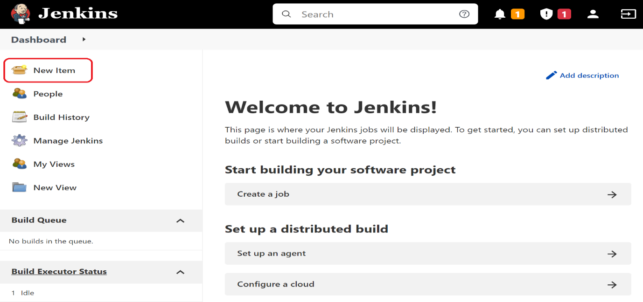

Figure 12.3 Jenkins job console output

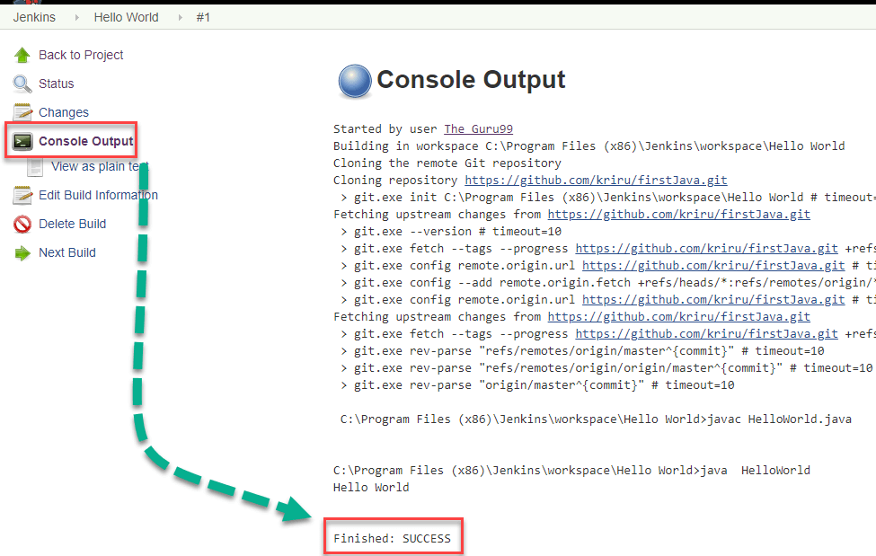

Figure 12.4 Gitlab Gui

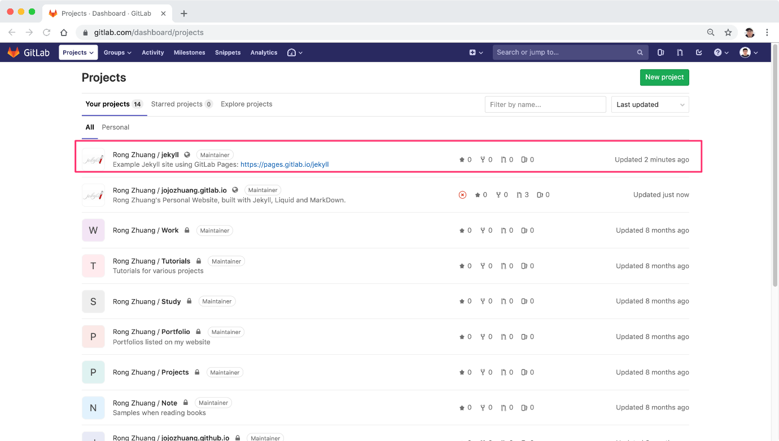

Figure 12.5 Setting up an SSH connection

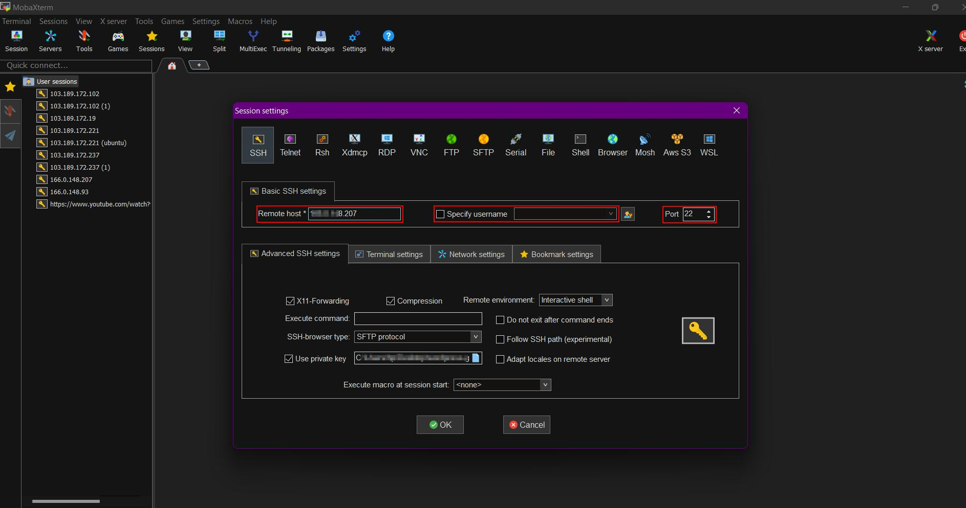

Figure 12.6 OpenStack dashboard

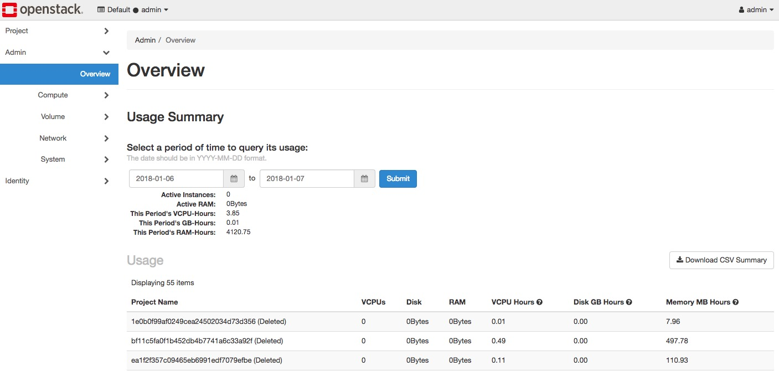

**APPENDIX-C**

**ENCLOSURES**

**1. Journal publication/Conference Paper Presented Certificates (if any).**

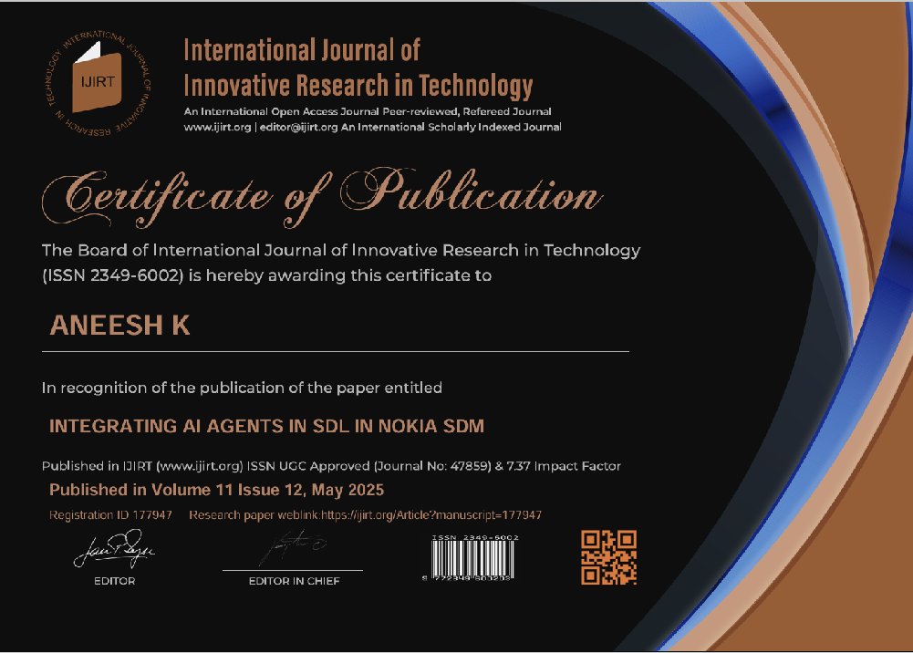

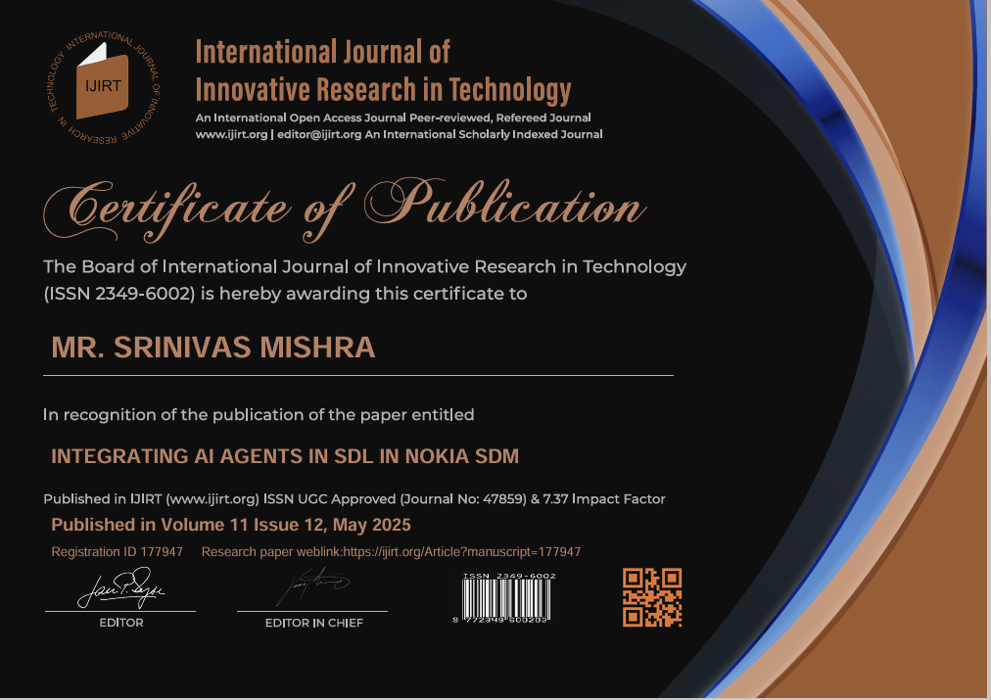

**2. Include certificate(s) of any Achievement/Award won in any project-related event.**

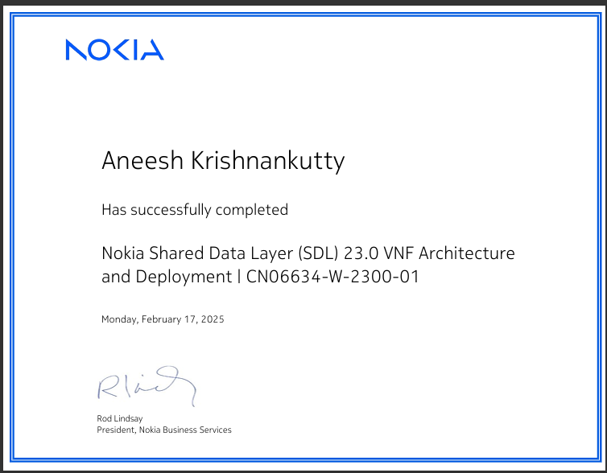

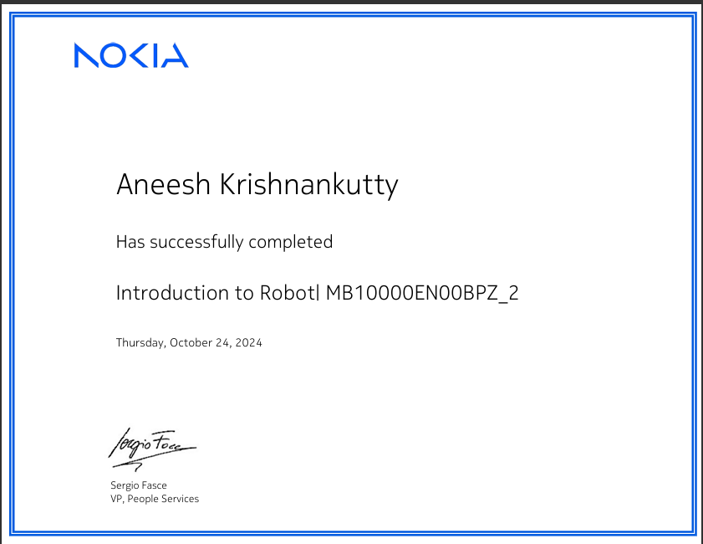

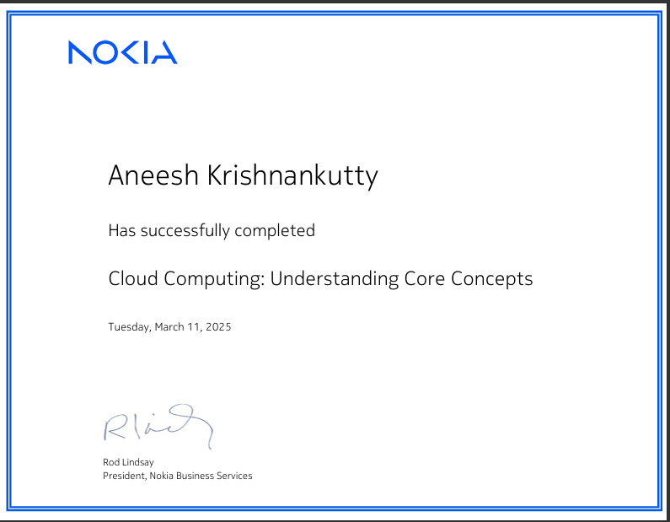

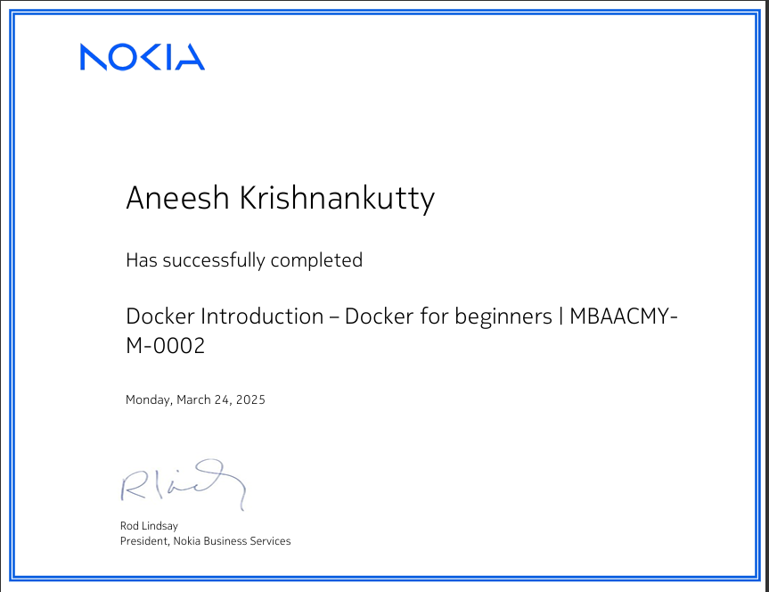

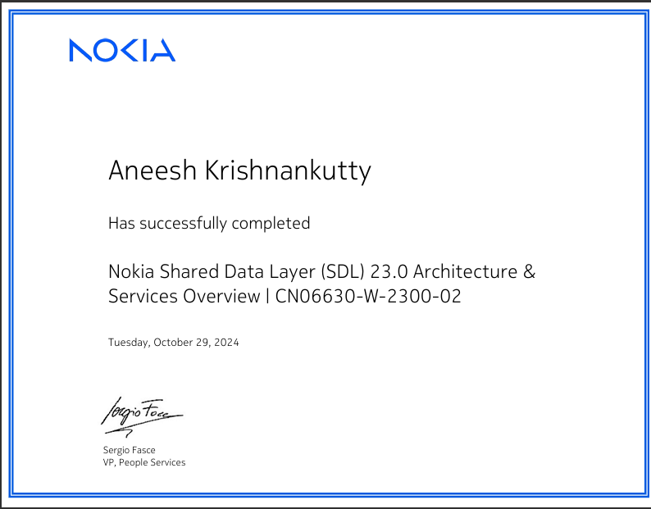

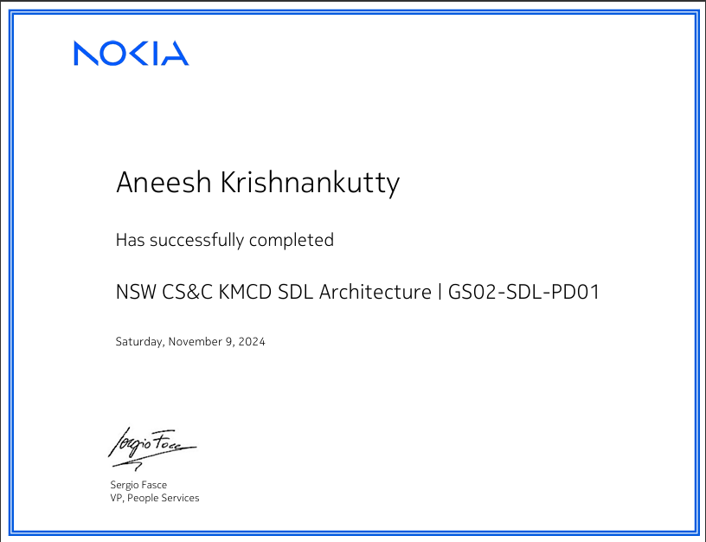

**3. Similarity Index / Plagiarism Check report clearly showing the Percentage (%). No need for a page-wise explanation.**

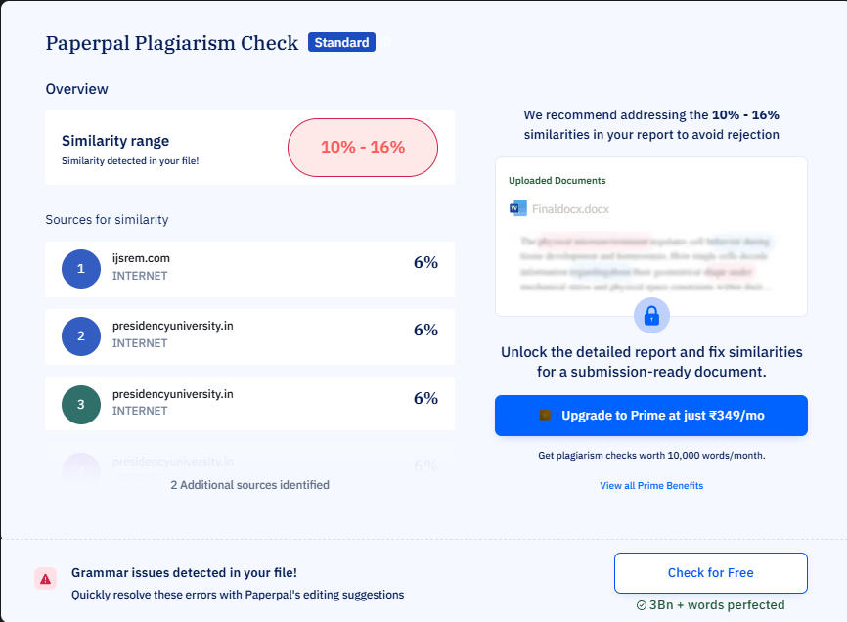

**4.** **Details of mapping the project with the Sustainable Development Goals (SDGs).**

**SUSTAINABLE DEVELOPMENT GOALS**



**7. Ensure that everyone has access to modern, affordable, dependable, and sustainable energy.**

Power utilities need mission-critical communications networks. End users would benefit from improved quality and possible cost savings due to sustainable power efficiency brought about by the digitalisation of power utilities. We collaborate with a variety of utilities and energy firms to assist them modernise, digitise, and improve operational efficiency and sustainability.

**8. Encourage employment, good work, and equitable and sustainable economic growth.**

Being a multinational corporation, we have a big economic influence, both directly and indirectly. Our purchases from suppliers, employee salaries and benefits, taxes paid to the government. Although we provide several indirect contributions to the economy, our biggest indirect influence is brought about by the advantages of the technologies we offer. According to our own study, COVID-19 enhances medium-long term investments, which means that by 2030, 5G-enabled sectors might contribute USD 8 trillion to the global GDP.

**9. Encourage innovation, encourage sustainable industrialisation, and construct robust infrastructure.**

When it comes to using technology to improve people's lives, this SDG is still the most relevant to us. It has a direct connection to the heart of our company. By the end of 2020, the network we provide to our clients supplied 6.6B subscriptions, creating an robust network and more.

**11. Create safe, resilient, sustainable, and inclusive cities.**

According to data from 2020, 56% of people on Earth reside in cities. Cities' infrastructure, services, and standard of living will be under more and more strain as they expand. The creation of smart cities that can handle and adapt to the expanding demands of urban life will be fuelled by technologies like 5G, the Internet of Things, artificial intelligence, and data analytics software. For instance, we are collaborating with the city of Leuven, Belgium, on the Leuven Digital City Pole project, where we are supplying private wireless that is suitable for 5G. The project's goal is to IOT to IOE.

**12. Make sure patterns of production and consumption are sustainable.**

The resources of the earth are finite. Better production, circularity, and consumption patterns, increased supply chain transparency, and increased industry efficiency are already being achieved through the use of AI, the IOT, blockchain, and sensors. A circular approach to business reduces the use of virgin natural resources and results in more efficient and waste-free consumption habits. We provide our clients with Asset Recovery services, which allow us to recycle, reuse, and restore outdated telecom equipment from both our own and other manufacturers.

**17. Bring the international alliance for sustainable development back to life.**

We collaborate with a variety of stakeholders to advance sustainable development and generate wealth that benefits everyone. Customers, suppliers, NGOs, authorities, governments, other industries, and associations are some examples of these.